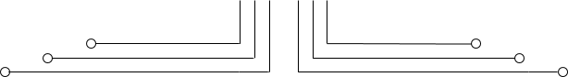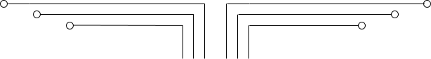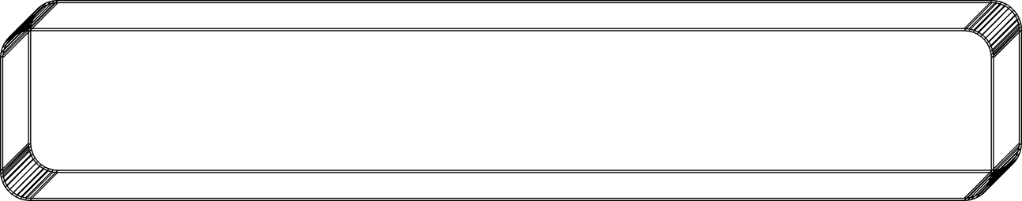

**1 D4 - TEKKOM B**

**FINITE STATE MACHINE**



Nama Kelas NRP

Dosen

Mata Kuliah

: Septian Bagus Jumantoro

: 1 – D4 Teknik Komputer B

: 3221600039

: Reni Soelistijorini B.Eng., MT.

: Praktikum Rangkaian Logika 2

Hari,Tgl. Praktikum : Jumat, 3 Juni 2022



# Tujuan

* 1. Menerapkan metode FSM dalam VHDL untuk sistem kendali pada simulasi trafic light
  2. Menampilkan simulasi sistem kendali pada simulasi trafic light untuk mengetahui aliran setiapperubahan state.

1. **Teori**

Finite State Machines (FSM) adalah sebuah metodologi perancangan sistem kontrol yang menggambarkan tingkah laku atau prinsip kerja sistem dengan menggunakan tiga hal berikut: State (Keadaan), Event (kejadian) dan action (aksi). Pada satu saat dalam periode waktu yang cukup signifikan, sistem akan berada pada salah satu state yang aktif. Sistem dapat beralih atau bertransisimenuju state lain jika mendapatkan masukan atau event tertentu, baik yang berasal dari perangkat luar atau komponen dalam sistemnya itu sendiri (misal interupsi timer). Transisi keadaan ini umumnya juga disertai oleh aksi yang dilakukan oleh sistem ketika menanggapi masukan yang terjadi. Aksi yang dilakukan tersebut dapat berupa aksi yang sederhana atau melibatkan rangkaian proses yang relative kompleks.

Berdasarkan sifatnya, metode FSM ini sangat cocok digunakan sebagai basis perancangan perangkat lunak pengendalian yang bersifat reaktif dan real time. Salah satu keutungan nyata penggunaan FSM adalah kemampuannya dalam mendekomposisi aplikasi yang relative besar dengan hanya menggunakan sejumlah kecil item state. Selain untuk bidang kontrol, Penggunaan metode ini pada kenyataannya juga umum digunakan sebagai basis untuk perancangan protokol‐protokol komunikasi, perancangan perangkat lunak game, aplikasi WEB dan sebagainya. Dalam bahasa pemrograman prosedural seperti bahasa C, FSM ini umumnya direalisasikan dengan menggunakan statemen kontrol switch case atau/dan if..then. Dengan menggunakan statemen‐statemen kontrol ini, aliran program secara praktis akan mudah dipahami dan dilacak jika terjadi kesalahan logika.

DIAGRAM KEADAAN

Diagram keadaan pada dasarnya merupakan salah satu bentuk representasi dari FSM. Diagram ini secara visual menggambarkan tingkah laku yang dimiliki oleh sistem kontrol yang kompleks kedalambentuk yang lebih sederhana dan relative mudah dipahami. Dalam diagram ini, state‐state yang terdapat pada sebuah sistem digambarkan sebagai lingkaran yang diberi label unik, sedangkan transisi state yang diakibatkan oleh event tertentu direpresentasikan sebagai anak panah yang berasal dari state yang ditinggalkan menuju statecvyiaiing aktif. Setiap transisi yang terjadi umumnya

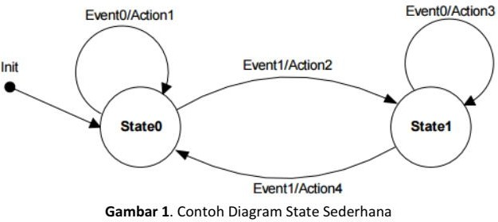juga diikuti oleh aksi yang dilakukan oleh sistem yang dirancang. Secara praktis setiap diagram state yang dirancang akan selalu memiliki sebuah transisi awal (inisial) yang menuju salah satu state sejak sistem kontrol tersebut mulai dihidupkan. Gambar 1. berikut memperlihatkan contoh penggambarandiagram state:

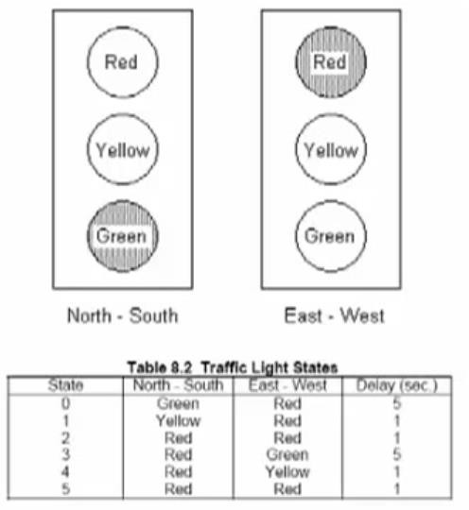**Trafic Light**

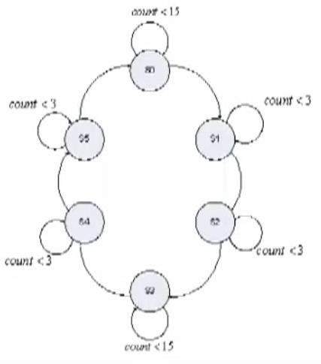**State Diagram for controlling Traffic Lights**

1. **Peralatan**
2. PC yang sudah terinstal ISE 13.1
3. Xilinx Spartan 3
4. Downloader JTAG USB
5. Power Supply 5 volt
6. **Langkah percobaan**
7. Buatlah ***new project*** dengan nama **Lab9.**
8. Tambahkan program VHDL dibawah ini.

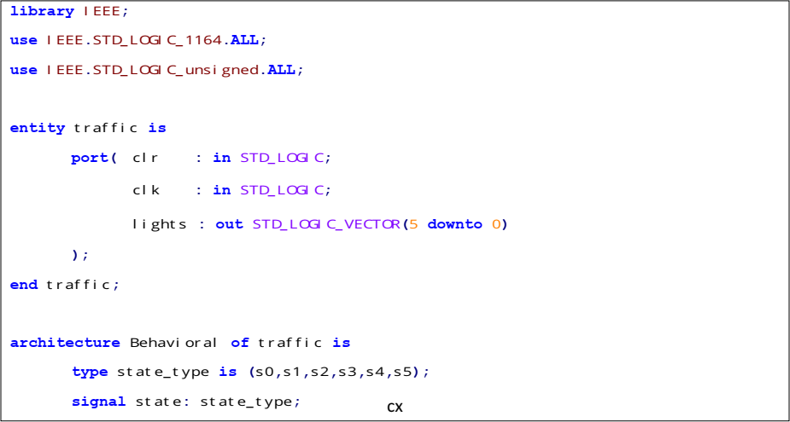

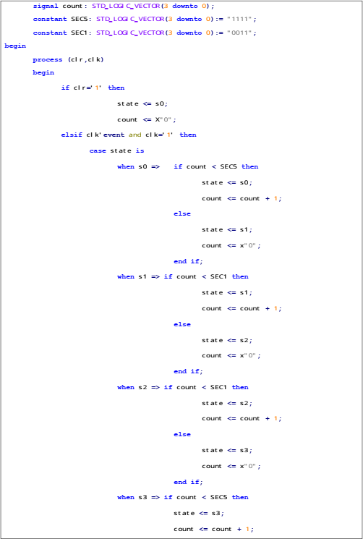

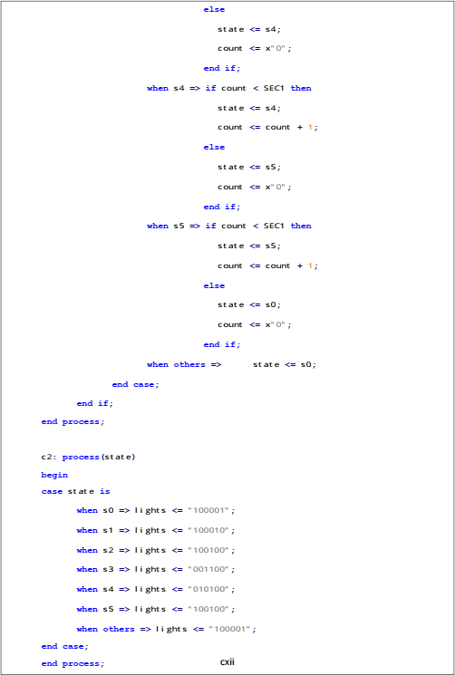



1. Lakukan sintesis dan uplaod program ke board spartan‐3, amati hasilnya dan dan demokanhasilnya ke dosen pengampu.
2. **Hasil Percobaan**
   1. **Langkah Percobaan Foto Praktikum**

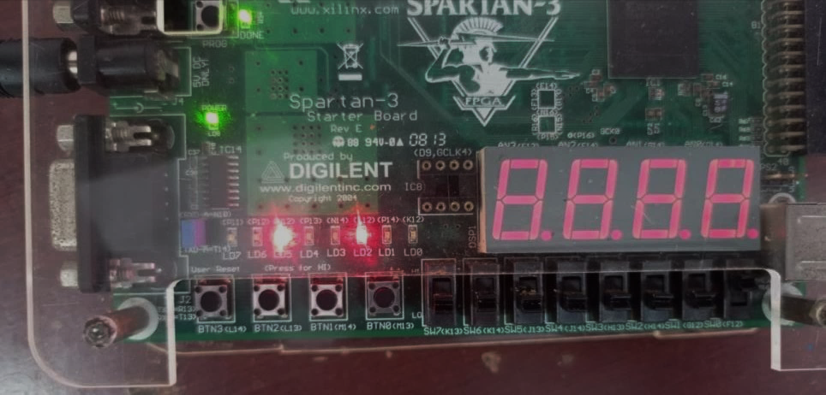

***Gambar 1 : Hasil pada FPGA dari Langkah Percobaan***

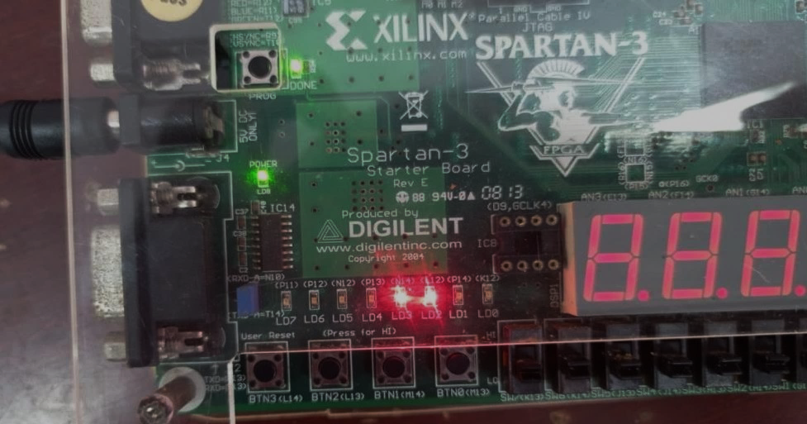

***Gambar 2 : Hasil pada FPGA dari Langkah Percobaan***

* 1. **Latihan Traffic Light Kode Program**

Clock Divider

library IEEE;

use IEEE.STD_LOGIC_1164.ALL;

use IEEE.STD_LOGIC_unsigned.ALL;

entity clkdiv is

Port ( mclk : in STD_LOGIC;

clr : in STD_LOGIC; clk190 : out STD_LOGIC; clk48 : out STD_LOGIC);

end clkdiv;

architecture Behavioral of clkdiv is

signal q : std_logic_vector(23 downto 0);

begin

process(mclk,clr) begin

if clr ='1' then

q <= x"000000";

elsif mclk' event and mclk ='1' then q <= q + 1;

end if;

clk48 <= q(20); clk190 <= q(17);

end process; end Behavioral;

Traffic Light

library IEEE;

use IEEE.STD_LOGIC_1164.ALL;

use IEEE.STD_LOGIC_unsigned.ALL;

entity trafficlight is port( clr : in STD_LOGIC;

clk : in STD_LOGIC;

lights : out STD_LOGIC_VECTOR(5 downto 0)

);

end trafficlight;

architecture Behavioral of trafficlight is type state_type is (s0,s1,s2,s3,s4,s5); signal state: state_type;

signal count : STD_LOGIC_VECTOR(3 downto 0);

constant SEC5: STD_LOGIC_VECTOR(3 downto 0):= "1111";

constant SEC1: STD_LOGIC_VECTOR(3 downto 0):= "0011";

begin

process (clr,clk) begin

if clr='1' then

state <= s0; count <= X"0";

elsif clk' event and clk='1' then case state is

when s0 => if count < SEC5 then

else

state <= s0;

count <= count + 1;

state <= s1; count <= x"0";

end if; when s1 => if count < SEC1 then

else

state <= s1;

count <= count + 1;

state <= s2; count <= x"0";

end if; when s2 => if count < SEC1 then

else

state <= s2;

count <= count + 1;

state <= s3; count <= x"0";

end if; when s3 => if count < SEC5 then

else

state <= s3;

count <= count + 1;

state <= s4; count <= x"0";

end if; when s4 => if count < SEC1 then

else

state <= s4;

count <= count + 1;

state <= s5; count <= x"0";

end if; when s5 => if count < SEC1 then

else

state <= s5;

count <= count + 1;

state <= s0; count <= x"0";

end if; when others => state <= s0;

end case; end if;

end process;

process(state) begin

case state is

when s0 => lights <= "100001"; when s1 => lights <= "100010"; when s2 => lights <= "100100"; when s3 => lights <= "001100"; when s4 => lights <= "010100"; when s5 => lights <= "100100";

when others => lights <= "100001"; end case;

end process; end Behavioral;

Decoder 7 segment

library IEEE;

use IEEE.STD_LOGIC_1164.ALL;

use IEEE.STD_LOGIC_unsigned.ALL;

entity decoder7seg is

port( x : in STD_LOGIC_VECTOR(15 downto 0);

clk : in STD_LOGIC; clr : in STD_LOGIC;

y : out STD_LOGIC_VECTOR(6 downto 0); an : out STD_LOGIC_VECTOR(3 downto 0); dp : out STD_LOGIC

);

end decoder7seg;

architecture Behavioral of decoder7seg is signal s : STD_LOGIC_VECTOR(1 downto 0);

signal digit : STD_LOGIC_VECTOR(3 downto 0); signal aen : STD_LOGIC_VECTOR(3 downto 0); signal clkdiv : STD_LOGIC_VECTOR(20 downto 0);

begin

s <= clkdiv(20 downto 19); aen <= "1111";

dp <= '1';

process(s,x) begin

case s is

when "00" => digit <= x(3 downto 0); when "01" => digit <= x(7 downto 4); when "10" => digit <= x(11 downto 8); when others => digit <= x(15 downto 12);

end case; end process; process(digit) begin

case digit is

when "0001" => y <= "1111110";

when "0010" => y <= "1110111";

when "0100" => y <= "0111111";

when others => y <= "1111111"; end case;

end process;

process(clk,clr) begin

if clr = '1' then

clkdiv <= (others => '0'); elsif clk' event and clk = '1' then

clkdiv <= clkdiv+1;

end if; end process;

end Behavioral;

**Top Level**

library IEEE;

use IEEE.STD_LOGIC_1164.ALL;

use IEEE.STD_LOGIC_unsigned.ALL;

entity traffic is

port( clr : in STD_LOGIC;

clk : in STD_LOGIC;

btn : in STD_LOGIC_VECTOR(3 downto 0); an : out STD_LOGIC_VECTOR(3 downto 0); y : out STD_LOGIC_VECTOR(6 downto 0); dp : out STD_LOGIC;

--x: in STD_LOGIC_VECTOR(7 downto 0) lights : out STD_LOGIC_VECTOR(5 downto 0)

);

end traffic;

architecture Behavioral of traffic is signal clk48,clk190 : STD_LOGIC;

signal light : STD_LOGIC_VECTOR(5 downto 0); signal x: STD_LOGIC_VECTOR(15 downto 0);

component clkdiv is

Port ( mclk : in STD_LOGIC;

clr : in STD_LOGIC; clk48 : out STD_LOGIC; clk190 : out STD_LOGIC);

end component;

component trafficlight is port( clr : in STD_LOGIC;

clk : in STD_LOGIC;

lights : out STD_LOGIC_VECTOR(5 downto 0)

);

end component;

component decoder7seg is

port( x : in STD_LOGIC_VECTOR(15 downto 0); clk : in STD_LOGIC;

clr : in STD_LOGIC;

y : out STD_LOGIC_VECTOR(6 downto 0); an : out STD_LOGIC_VECTOR(3 downto 0); dp : out STD_LOGIC

);

end component;

begin

lights <= light;

x <= "00000000"&'0'&light(5 downto 3) & '0'&light(2 downto 0);

u1 : clkdiv port map( clr => clr,

clk48 =>clk48, clk190 =>clk190);

mclk => clk,

u2 : trafficlight port map( clr => clr,

lights => light);

clk => clk48,

u3 : decoder7seg port map( clk => clk,

clr => clr, y => y,

an => an, dp => dp

);

end Behavioral;

x => x,

**Konfigurasi Pin**

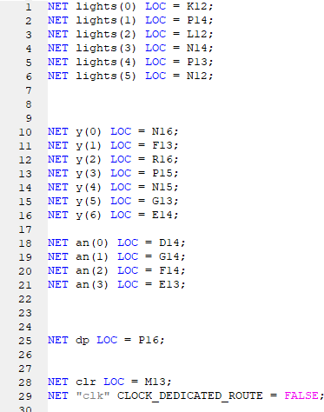

**Foto Praktikum**

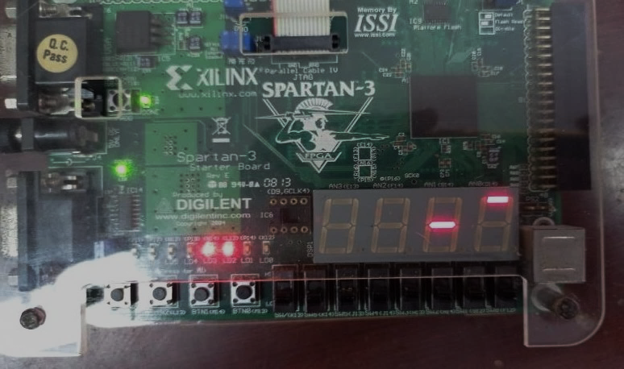

***Gambar 3 : Hasil pada FPGA dari Latihan***

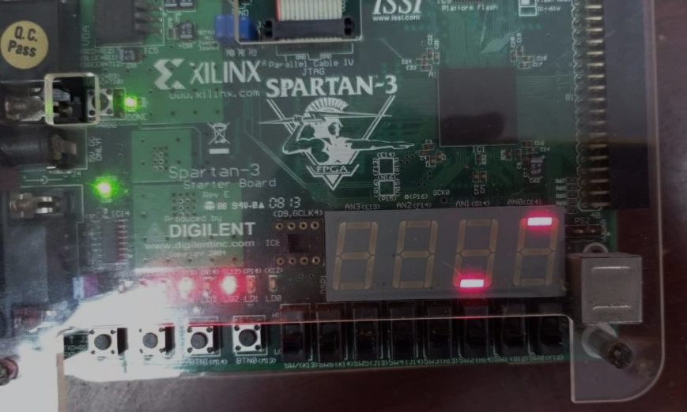

***Gambar 4 : Hasil pada FPGA dari Latihan***

**Vending Machine Kode Program VM Modul**

library IEEE;

use IEEE.STD_LOGIC_1164.ALL;

use ieee.std_logic_unsigned.all;

entity vm is

port(btn: in std_logic_vector (3 downto 0);

a: out std_logic_vector (3 downto 0);

b: out std_logic_vector (3 downto 0)

);

end vm;

architecture Behavioral of vm is

type state_type is(btn50,btn500,btn100,btn200,

btn150,btn250,btn550,btn350, btn650,btn750,btn600,btn700, btn300,btn800,btn850,nul);

signal p: state_type; begin

process(btn,p) begin

case btn is

when "0001" => p <=btn50; when "0010" => p <=btn100; when "0100" => p <=btn200; when "1000" => p <=btn500; when "0011" => p <=btn150; when "0101" => p <=btn250; when "1001" => p <=btn550; when "0110" => p <=btn300; when "1010" => p <=btn600; when "1100" => p <=btn700; when "0111" => p <=btn350; when "1011" => p <=btn650; when "1101" => p <=btn750; when "1110" => p <=btn800; when "1111" => p <=btn850; when others => p <=nul;

end case; end process;

process(p) begin

case p is

when btn50 => a<="0000"; b<="0101"; when btn100 => a<="0001"; b<="0000"; when btn200 => a<="0010"; b<="0000"; when btn500 => a<="0101"; b<="0000"; when btn150 => a<="0001"; b<="0101"; when btn250 => a<="0010"; b<="0101"; when btn350 => a<="0011"; b<="0101"; when btn550 => a<="0101"; b<="0101"; when btn650 => a<="0110"; b<="0101"; when btn750 => a<="0111"; b<="0101"; when btn850 => a<="1000"; b<="0101"; when btn300 => a<="0011"; b<="0000"; when btn600 => a<="0110"; b<="0000"; when btn700 => a<="0111"; b<="0000"; when btn800 => a<="1000"; b<="0000";

when others => a<="0000"; b<="0000"; end case;

end process;

end Behavioral;

**7 segment decoder**

use IEEE.STD_LOGIC_1164.ALL;

use IEEE.STD_LOGIC_unsigned.ALL;

entity x7seg is

Port ( x : in STD_LOGIC_VECTOR (15 downto 0); clk : in STD_LOGIC;

clr : in STD_LOGIC;

a_to_g : out STD_LOGIC_VECTOR (6 downto 0); an : out STD_LOGIC_VECTOR (3 downto 0);

dp : out STD_LOGIC);

end x7seg;

architecture percobaan7_C of x7seg is

signal s : STD_LOGIC_VECTOR (1 downto 0); signal digit : STD_LOGIC_VECTOR (3 downto 0); signal aen : STD_LOGIC_VECTOR (3 downto 0); signal clkdiv : STD_LOGIC_VECTOR (20 downto 0); begin

s <= clkdiv(20 downto 19); aen <= "1111" ;

dp <= '1' ;

-- Quad 4 to 1 mux process(s,x)

begin

case s is

when "00" => digit <=x(3 downto 0); when "01" => digit <=x(7 downto 4); when "10" => digit <=x(11 downto 8); when others => digit <=x(15 downto 12);

end case; end process;

-- 7- segment decoder : hex7seg process(digit)

|  |  |  |  |  |  |  |  |  |  |  |  |
| --- | --- | --- | --- | --- | --- | --- | --- | --- | --- | --- | --- |
| begin | case | digit is |  | | | | | | | | |
|  |  |  | when | "0000" | => | a_to_g | <= | "0000001" | ; | -- | 0 |
|  |  |  | when | "0001" | => | a_to_g | <= | "1001111" | ; | -- | 1 |
|  |  |  | when | "0010" | => | a_to_g | <= | "0010010" | ; | -- | 2 |
|  |  |  | when | "0011" | => | a_to_g | <= | "0000110" | ; | -- | 3 |
|  |  |  | when | "0100" | => | a_to_g | <= | "1001100" | ; | -- | 4 |
|  |  |  | when | "0101" | => | a_to_g | <= | "0100100" | ; | -- | 5 |
|  |  |  | when | "0110" | => | a_to_g | <= | "0100000" | ; | -- | 6 |
|  |  |  | when | "0111" | => | a_to_g | <= | "0001111" | ; | -- | 7 |
|  |  |  | when | "1000" | => | a_to_g | <= | "0000000" | ; | -- | 8 |
|  |  |  | when | "1001" | => | a_to_g | <= | "0000100" | ; | -- | 9 |
|  |  |  | when | others | => | a_to_g | <= | "1111111" | ; | -- | null |

end case; end process;

-- Digit select : ancode process(s,aen)

begin

an <= "1111" ;

if aen(conv_integer (s))='1' then an(conv_integer (s))<='0' ;

end if; end process;

-- Clock devider process(clk,clr )

begin

if clr ='1' then

clkdiv <= (others => '0' );

elsif clk' event and clk='1' then clkdiv <= clkdiv+1;

end if; end process;

end percobaan7_C;

# Top Level

library IEEE;

use IEEE.STD_LOGIC_1164.ALL;

use ieee.std_logic_unsigned.all; use IEEE.NUMERIC_STD.ALL;

entity topvm is

port(input: in std_logic_vector (3 downto 0); clk : in STD_LOGIC;

clr : in STD_LOGIC;

a_to_g : out STD_LOGIC_VECTOR (6 downto 0); an : out STD_LOGIC_VECTOR (3 downto 0);

dp : out STD_LOGIC);

end topvm;

architecture Behavioral of topvm is component x7seg is

Port ( x : in STD_LOGIC_VECTOR (15 downto 0); clk : in STD_LOGIC;

clr : in STD_LOGIC;

a_to_g : out STD_LOGIC_VECTOR (6 downto 0); an : out STD_LOGIC_VECTOR (3 downto 0);

dp : out STD_LOGIC);

end component; component vm is

port(btn: in std_logic_vector (3 downto 0);

a: out std_logic_vector (3 downto 0);

b: out std_logic_vector (3 downto 0)

);

end component;

signal a: std_logic_vector (3 downto 0);

signal b: std_logic_vector (3 downto 0);

signal x: STD_LOGIC_VECTOR (15 downto 0); begin

x<="0000" & a(3 downto 0) & b(3 downto 0) & "0000"; u1: vm port map(

btn => input, a => a,

b => b); u2: x7seg port map(

x => x, clk => clk, clr => clr,

a_to_g => a_to_g, an => an,

dp => dp);

end Behavioral;

**Konfigurasi Pin**

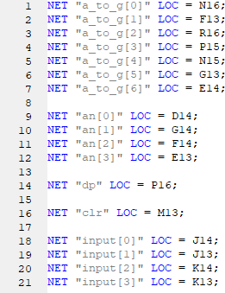

**Foto Praktikum**

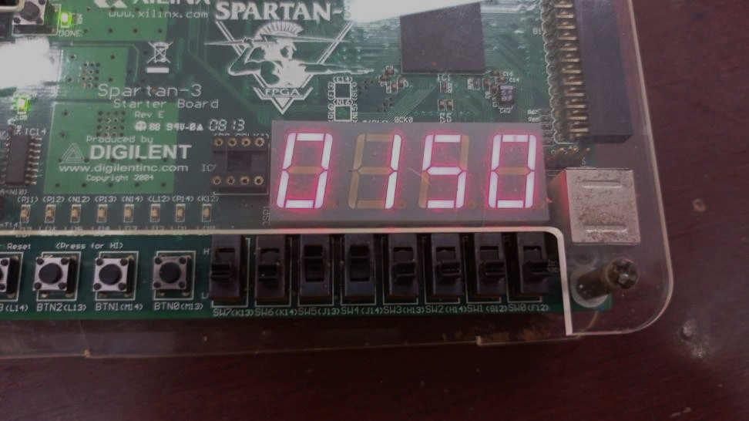

***Gambar 5 : output 7 seg display dengan input 0011***

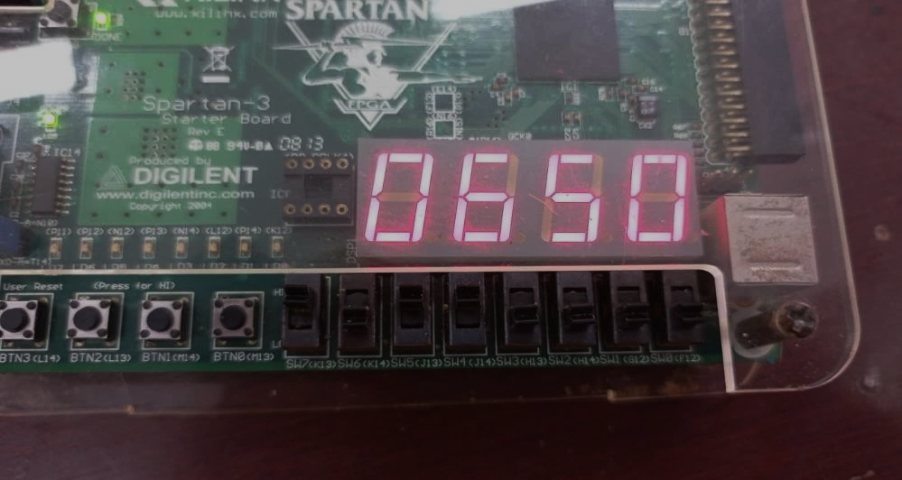

***Gambar 6 : output 7 seg display dengan input 1011***

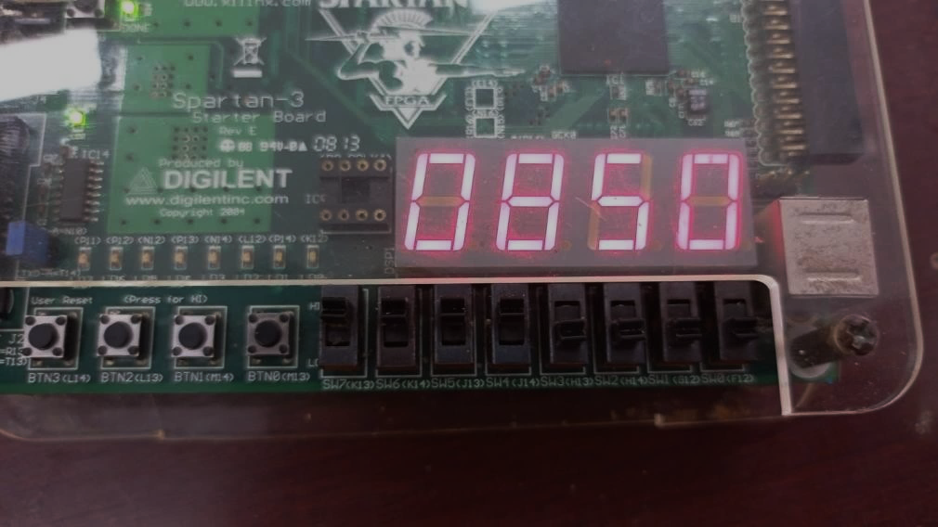

***Gambar 7 : output 7 seg display dengan input 1111***

1. **Analisa**

